REG NO: 21RP06137
EAT STREAM B
PROJECT NAME: SMART DUSTBIN.
Intoduction:Dustbins (or Garbage bins, Trash Cans, whatever you call them) are small plastic (or metal) containers that are used to store trash (or waste) on a temporary basis.
Smart bin not only makes waste collection and handling extremely convenient but also helps in maintaining a garbage-free and sustainable environment for the public.
Smart Dustbin is integrated with some hardware components such as Arduino, NODEMCU, Servo Motor, Ultrasonic sensors. These components help in opening the lid, on detection of human hand and waste.
OBJCTIVES OF SMART DUSTBIN.
to create a cleaner, safer, more hygienic environment and enhanced operational efficiency while reducing management costs, resources, and road-side emissions.

WORKING PRINCIPLE OF SMART DUSTBIN
The smart dustbin uses an Ultrasonic sensor HC-SR04 to detect objects in front. It then sends the signals to Arduino Uno. The Arduino understands the signal and sends a signal to the Servomotor which opens the
flap on top of the dustbin.

Smart Dustbin works on the principle of object detection using an ultrasonic sensor. The ultrasonic sensor transmits sound waves. These waves get reflected whenever an object comes into the vicinity of the sensor. This generates an electrical signal which is used to open the dustbin lid.

WHERE APPLICABLE OF SMART DUSTBIN.
It is perfect for areas with a large volume of human traffic, such as parks, academic institutes, malls, hospitals, etc. Cities are not required to install smart bins and forget about the traditional bins if they

want to improve waste collection and recycling efficiency.
BLOCK DIAGRAM OF SMART DUSTBIN.

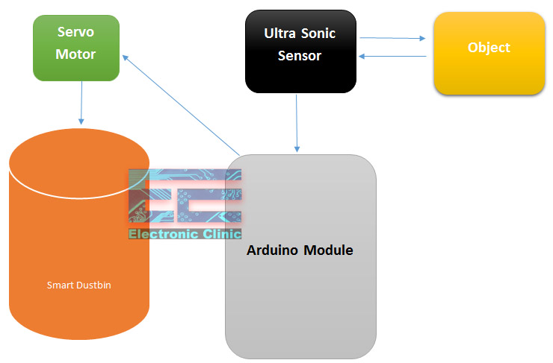

WIRING DIAGRAM OF SMART DUSTBIN.
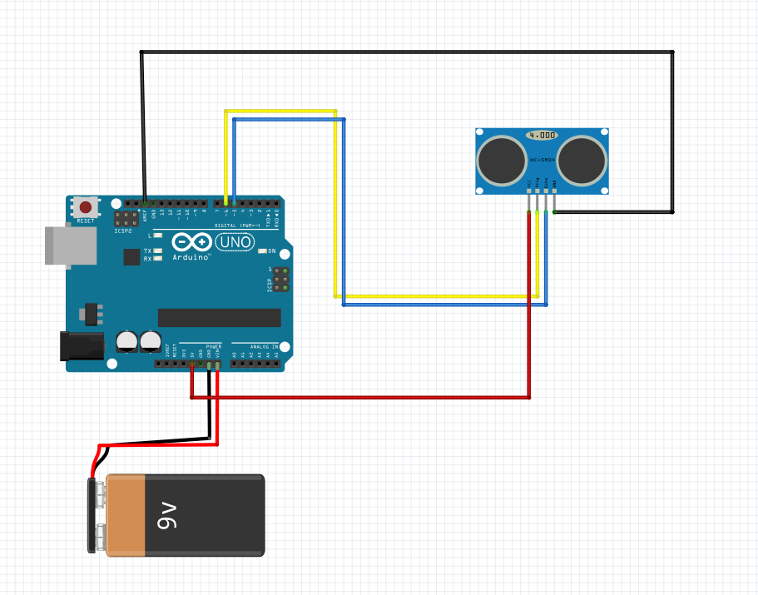

PERPOSES OF ANY PROJECT COMPONENTS IN MY

1 .ARDUINO UNO BOARD

Arduino UNO is a low-cost, flexible, and easy-to-use programmable open-source microcontroller board that can be integrated into a variety of electronic projects. This board can be interfaced with other Arduino boards, Arduino shields, Raspberry Pi boards and can control relays, LEDs, servos, and motors as an output.

2. UILTRASONIC SENSOR

Ultrasonic sensors work by sending out a sound wave at a frequency above the range of human hearing. The transducer of the sensor acts as a microphone to receive and send the ultrasonic sound. Our ultrasonic sensors, like many others, use a single transducer to send a pulse and to receive the echo.

3 .SERVO MOTOR
Servo motors or “servos”, as they are known, are electronic devices and rotary or linear actuators that rotate and push parts of a machine with precision. Servos are mainly used on angular or linear position and for specific velocity, and acceleration.

4 .BREAD BOARD

A breadboard (sometimes called a plugblock) is used for building temporary circuits. It is useful to designers because it allows components to be removed and replaced easily. It is useful to the person who wants to build a circuit to demonstrate its action, then to reuse the components in another circuit.

5. JUMPER WIRES

A jumper wire is an electric wire that connects remote electric circuits used for printed circuit boards. By attaching a jumper wire on the circuit, it can be short-circuited and short-cut (jump) to the electric circuit.

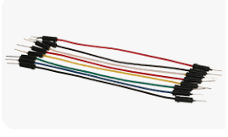

6. BA TTERY (9V)

What Is The 9V Battery Used For? The 9V battery is used in many different applications. 9 volt batteries can frequently be seen used in radios, smoke alarms, wall clocks, walkie-talkies, portable electronics, and much more.

CODE USING TO PERFORM OR TO RUN THIS PROJECT.
#include<Servo.h>
Servo myservo;
int pos=20;
const int trigpin=5;
const int echopin=6;

long duration;
float distance;

void setup()
{
myservo.attach(11);
pinMode(trigpin,OUTPUT);
pinMode(echopin,INPUT);

myservo.write(pos);

}
void loop()
{

digitalWrite(trigpin,LOW);
delayMicroseconds(2);
digitalWrite(trigpin,HIGH);
delayMicroseconds(10);
digitalWrite(trigpin,LOW);

duration=pulseIn(echopin,HIGH);
distance=0.034*(duration/2);

if(distance<90)
{
myservo.write(pos+160);
delay(1000);

}
else
{
myservo.write(pos);

}
delay(300);
}

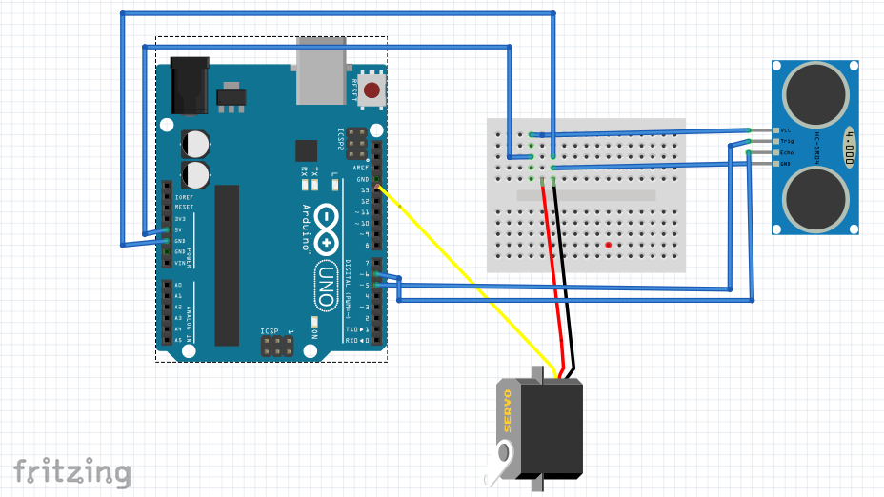

CONCLUSION ABOUT SMART DUSTIBIN.
Conclusion. A simple but useful project called Smart Dustbin using Arduino is designed and developed here. Using this project, the lid of the dustbin stays closed, so that waste is not exposed (to avoid flies and mosquitos) and when you want dispose any waste, it will automatically open the lid.

